*A model of user following through an intermediate Relationship model.*

Let’s say Michael Hartl is following Hobbes, and Hobbes is followed by Michael.  
So **Michael is the *follower*** and **Hobbes is *followed***.

**followed_id** should be accessible, *since users will create  
 relationships through the web*. (as model’s accessible attr) **follower_id** attribute should not be   
accessible; otherwise, malicious *users   
could force other users to follow them*.  
 **user.following** will contain an array of the users being  
 followed.

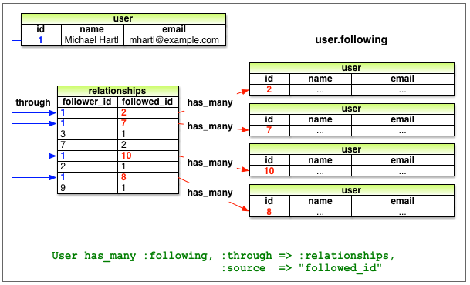

**user.following** will contain an array of the users being followed.   
**user.followers** will be an array of all users following a given user